Let us establish a convention for labels. This is to make our code neat, uniform, and avoid label-collision.

I suggest using camel casing for individual labels:
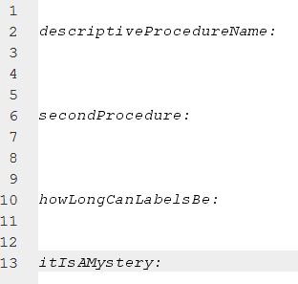

For labels within a procedure (sub labels/ branches/ w.e) we shall append them to the original procedure name using an underscore. Camel casing will still be used for these labels. If these labels have sub labels continue appending using underscores.
